**Name:** Chandana Ramesh Galgali

**Batch:** P6-1 **Roll No.:** 16010422234

**Date:** 21/04/2023

**Experiment No. 6**

**Title:** Determination of Viscosity Average Molecular Weight of Polymer

**Aim:** To determine the viscosity average molecular weight of a polymer.

**Theory:**

Viscosity is an internal property of a fluid that offers resistance to flow. It is due to the internal friction of molecules and  mainly depends on the nature & temperature of the liquid. Many methods are available for measuring viscosity of polymer solution. The Ostwald method is a simple method for the measurement of viscosity, in which viscosity of liquid is measured by comparing the viscosity of an unknown liquid with that of liquid whose viscosity is known. In this method viscosity of liquid is measured by comparing the flow times of two liquids of equal volumes using the same viscometer.

Consider two liquids passing through a capillary of the same viscometer. Then the coefficient of viscosity of liquid (η2) is given by equation



Here*t1* and*t2* are the time of flow of the liquids and*ρ1* and *ρ2* are the respective densities. And *η1* is the coefficient of viscosity of water.

For a given liquid *η* has a specific value at the same temperature.

Various mixtures of two non-interacting liquids viscosities will lie among the viscosities of those pure components.

The time of flow of liquid depends on the viscosity and composition. In this method the flow times are measured for different known compositions and a graph is plot for time of flow and compositions. The unknown composition can be determined by plotting a graph for the time of flow and compositions.

The molecular weight of the polymer is measured by using a viscometer and the molecular weight obtained by this technique is called viscosity average molecular weight. The molecular weight of the polymer solution is very high so the viscosity of the polymer solution is very high compared to that of pure solvent.

From the Mark-Houwink equation the relationship among the molecular weight and viscosity are given below



Where is the intrinsic viscosity ,  is Molecular weight, ** and  are constants for a particular polymer solvent  system.

If we know the **and values for a given polymer solution the intrinsic viscosity and molecular weight can be calculated using the above equation.

| **Polymer-solvent system** | **K x 103 mL/g** |  |
| --- | --- | --- |
| PMMA-Acetone | 7.70 | 0.70 |
| PMMA-Benzene | 5.20 | 0.76 |
| PMMA-Toluene | 7.0 | 0.71 |
| Poly vinyl acetate-Acetone | 10.2 | 0.72 |
| Poly vinyl acetate-Benzene | 56.3 | 0.62 |
| Poly vinyl acetate-Acetonitrile | 41.5 | 0.62 |
| Poly vinyl alcohol-Water | 45.3 | 0.64 |
| Poly styrene-Benzene | 10.6 | 0.735 |
| Poly styrene-Toluene | 11.0 | 0.725 |

**Terms Related to Viscosity Measurements:-**

Relative Viscosity**= **

Specific Viscosity **= **

Reduced Viscosity = 

Inherent Viscosity =****

Intrinsic Viscosity =****

For measuring intrinsic viscosity of polymer sample, solutions of known concentrations are prepared, the flow times of solvent () and the solutions () are measured using a viscometer. Double extrapolation plots of reduced viscosity against concentration and inherent viscosity against concentration is plotted by calculating the corresponding reduced viscosity and inherent viscosity. The intrinsic viscosity is given by the common ordinate intercept of these graphs.

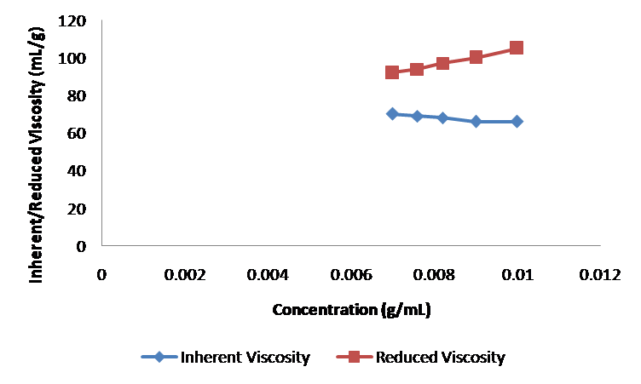

**Procedure:**

1. Select the Polymer.
2. Select the Solvent.
3. Determine the Time of flow of the solvent (t0).
4. Determine the time of flow of the polymer-solvent system at different concentrations.
5. From the concentration and time of flow, the inherent viscosity and reduced viscosity are calculated using the equations;
6. Inherent Viscosity = ,

Reduced Viscosity = 

1. A graph is drawn by plotting reduced viscosity against concentration and inherent viscosity against concentration.
2. Intrinsic viscosity can be obtained by extrapolating the graph to zero concentration.
3. From the value of intrinsic viscosity, the viscosity average molecular weight of the polymer can be calculated by using the equation: 

**Screenshots of the simulation:**

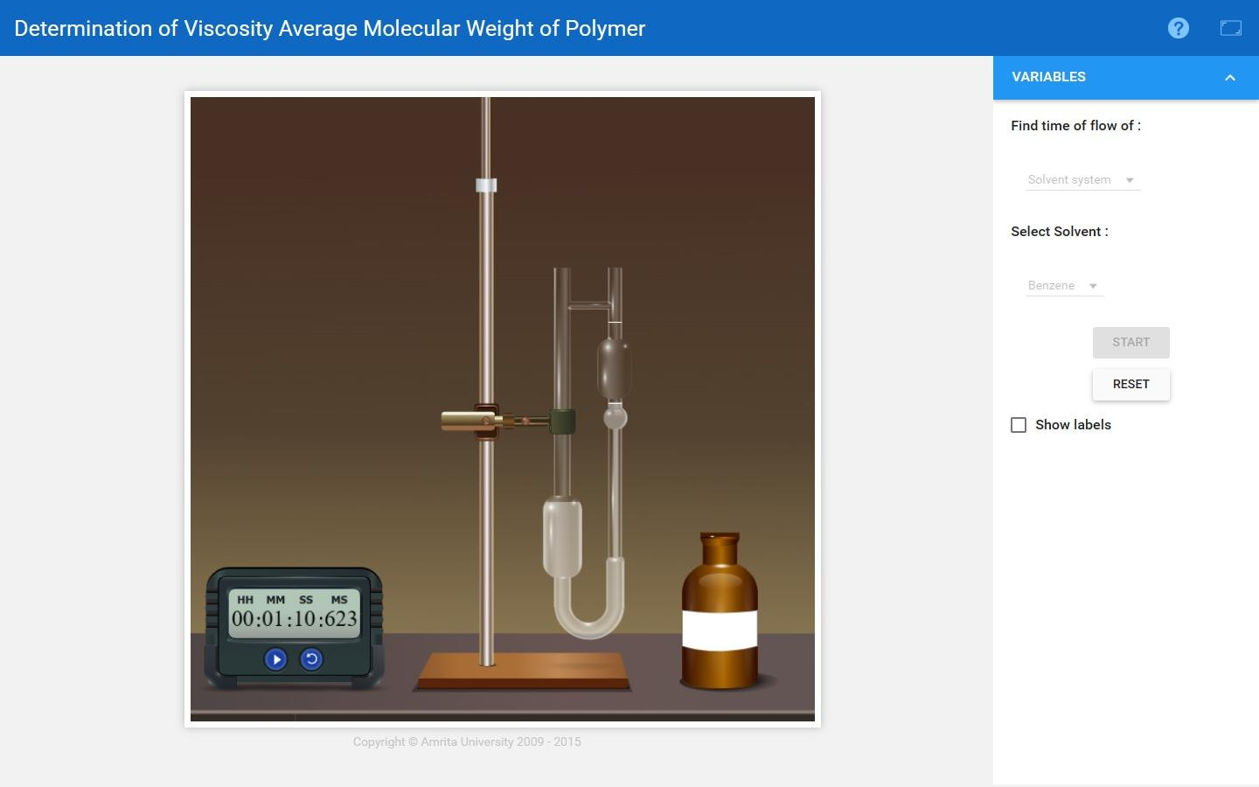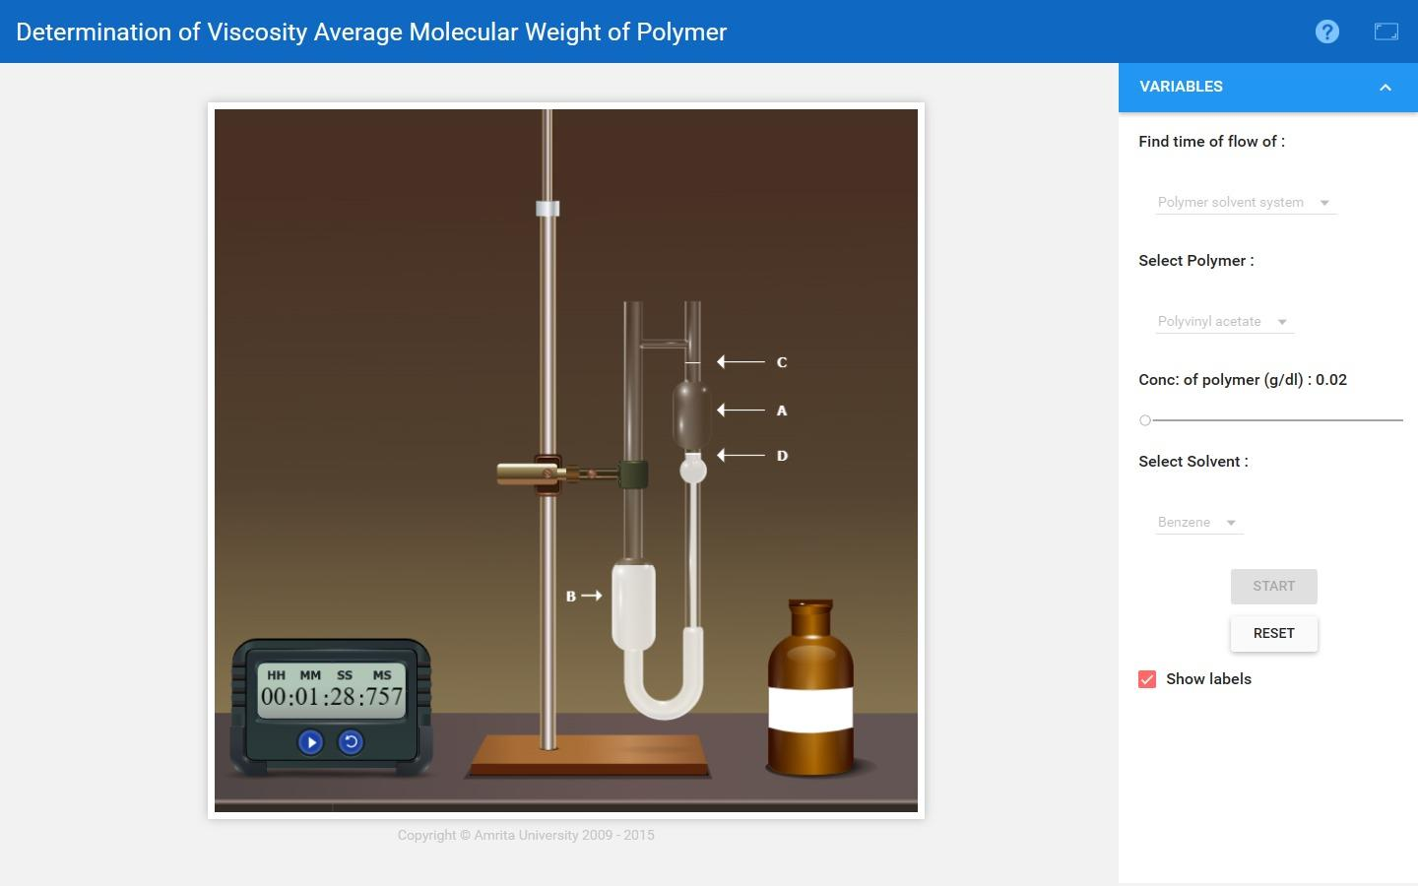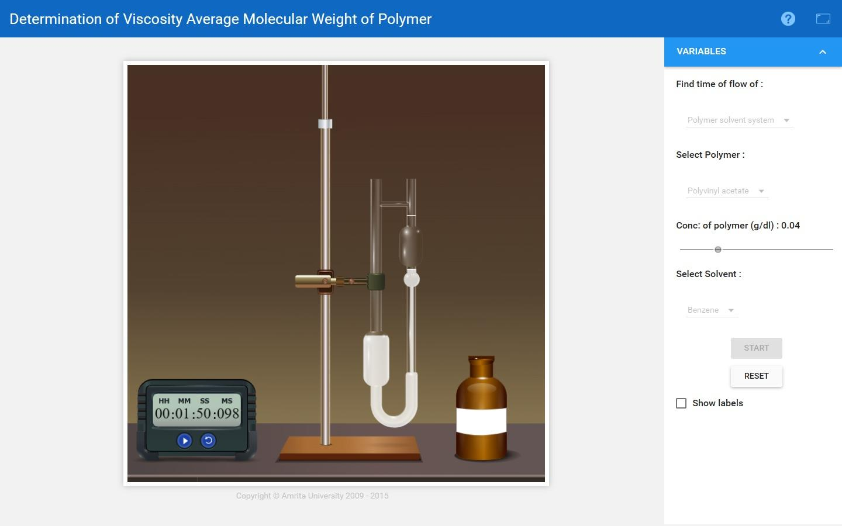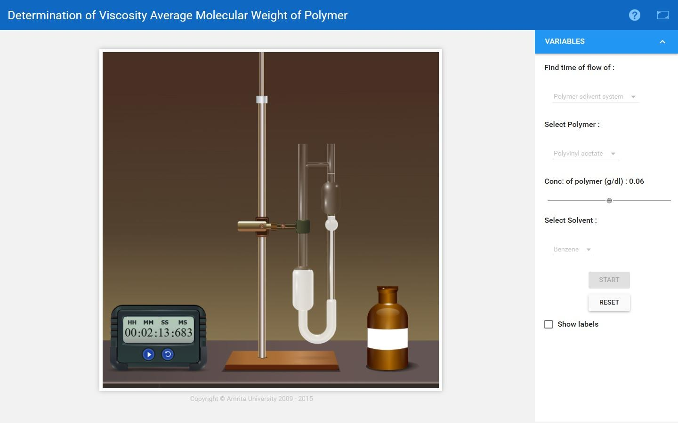

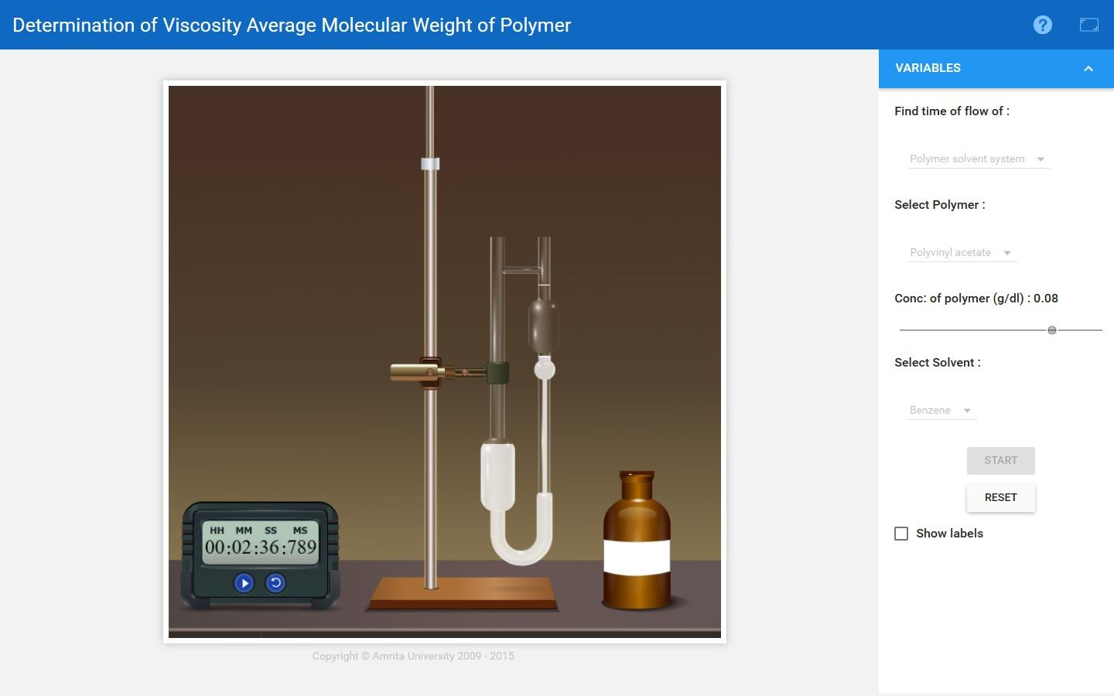

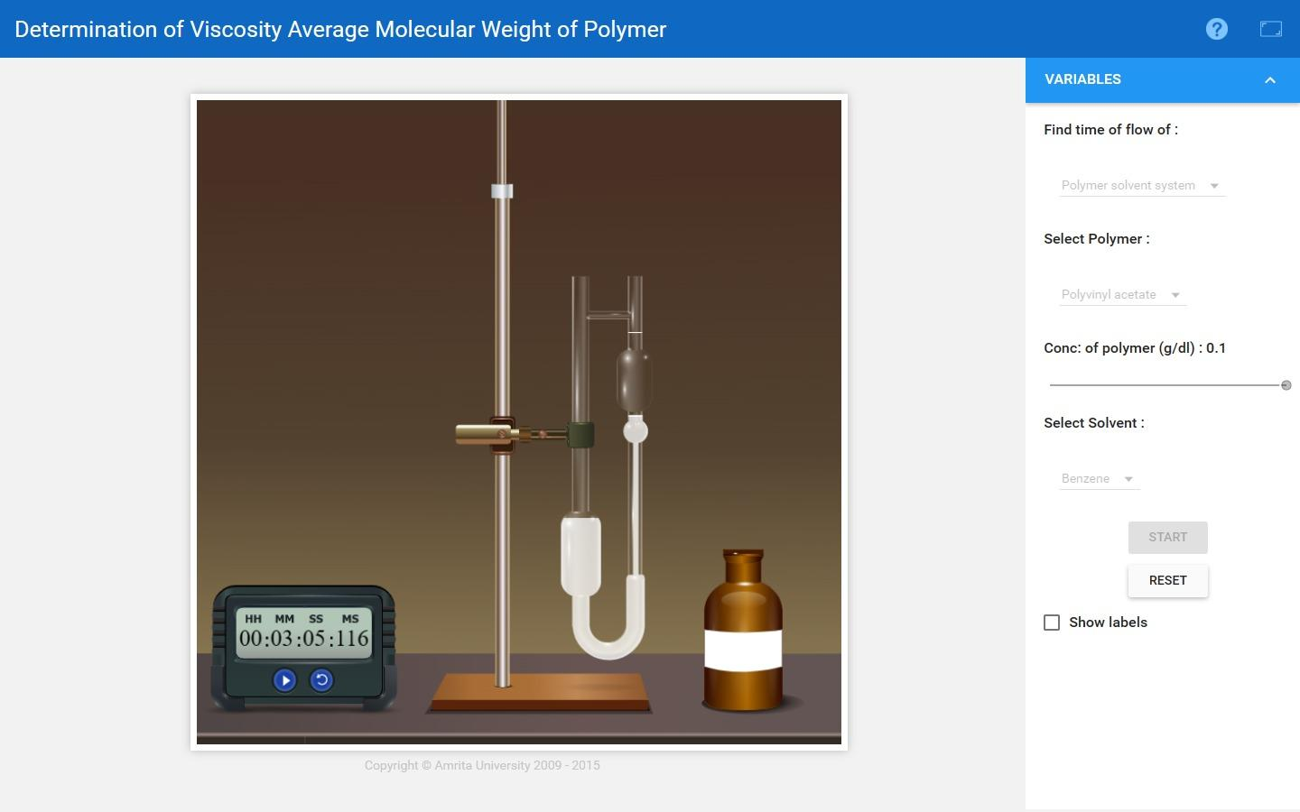

**Observations:**

| **Conc:**  **(g/ml)** | **Flow Time of Polymer-Solvent system**  **(t) sec** | **Flow Time of Solvent**  **(t0) sec** |  |  | **Reduced Viscosity** |  | **Inherent Viscosity** |
| --- | --- | --- | --- | --- | --- | --- | --- |
| 0.0002 | 88 | 70 | 1.2571 | 0.2571 | 1285.50 | 0.2288 | 1144.00 |
| 0.0004 | 110 | 70 | 1.5714 | 0.5714 | 1428.50 | 0.4520 | 1130.00 |
| 0.0006 | 133 | 70 | 1.9000 | 0.9000 | 1500.00 | 0.6418 | 1069.67 |
| 0.0008 | 156 | 70 | 2.2286 | 1.2286 | 1535.75 | 0.8014 | 1001.75 |
| 0.001 | 185 | 70 | 2.6428 | 1.6428 | 1642.80 | 0.9718 | 971.80 |

**Calculations:**

From the Mark-Houwink equation, $[η]=KM^{α}$

where:

$[η]=1290 mL/g$

For polyvinyl acetate-benzene system,

$K=56.3×{10}^{-3}mL/g$

$α=0.62$

Therefore, $M={\left\{\frac{[η]}{K}\right\}}^{\frac{1}{α}}={\left\{\frac{1290}{56.3 × {10}^{-3}}\right\}}^{\frac{1}{0.62}}=1.077430383×{10}^{7}g$

**Result:**

The viscosity average molecular weight of the polymer,

$M=1.077430383×{10}^{7}g$

**Self Evaluation:**

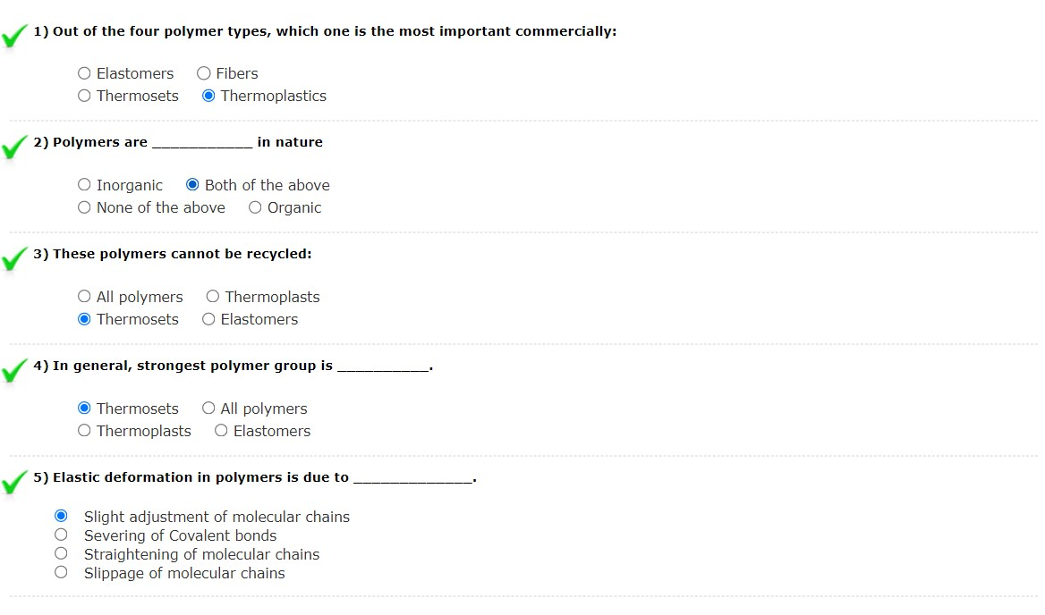

## **Assignments:**

1. Viscosity is an important property of a polymer melt in plastics shaping processes. Upon what three parameters does viscosity depend?

Ans: (1) Temperature

(2) Shear rate

(3) Molecular weight of the polymer

1. How does the viscosity of a polymer melt differ from most fluids that are Newtonian.

Ans: A polymer melt exhibits pseudoplasticity, which means that its value decreases with increasing shear rate.

1. What does viscoelasticity mean, when applied to a polymer melt?

Ans: Viscoelasticity is a combination of viscous and elastic properties which cause the melt to exhibit memory - the tendency to return to its previous shape, as exhibited by die swell in extrusion.

1. Which one of the following is the chemical formula for the repeating unit in polyethylene:

1. CH2 (b) C2H4 (c) C3H6 (d) C5H8 (e) C8H8

1. Use of a parison is associated with which one of the following plastic shaping processes:

1. bi-injection molding
2. blow molding
3. compression molding
4. pressure thermoforming